1. Yes we can achieve this in AI.
2. Below are the domain and stages.
3. Name of the Project is: **Employee procurement measure.**

Dummy data:

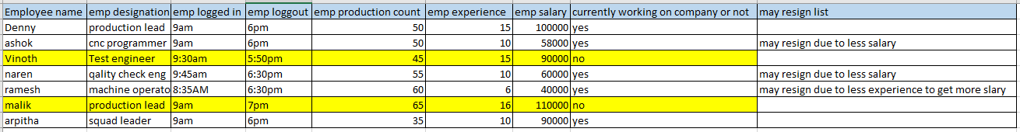

It’s a prediction.

Because we need to predict which employee may / may not leave the organization.

The given data in excel which is in text. So its falls under **Machine learning**.

ML. With this excel we have employee’s data as input and out is no of employee’s already left with what based they left.

So its stage is : **SUPERVISED**.

The category is **Classification, b**ecause we need to find employee may or may not leave the organization.